

**Software Requirements Specification**

***Banker Buddy***



CPSC 462

Professor: Dr. Lidia Morrison

Department of Computer Science

California State University, Fullerton

Fall, 2014

**Table of Contents**

**1. Introduction** 4

**1.1 Purpose** 4

**1.2 Scope of the Problem** 4

**1.3 Intended Audience** 4

**2. Overall Description** 5

**2.2 Product Functions** 5

**2.3 Operating Environment** 6

**2.4 Similar System Information** 6

**2.5 User Characteristics** 8

**2.6 Design and Implementation Constraints** 8

**2.7 Assumptions** 8

**3.0 Functional Requirements** 9

3.1 The app shall display a splash screen 9

3.2 The app shall display a login page 9

3.3 The app shall let the user create a new account 9

3.4 The app shall let the user save the new account details 10

3.5 The app shall display the home screen 10

3.6 The app shall allow the user make a deposit 10

3.7 The app shall display a confirmation screen 11

3.8 The app shall allow the user make withdrawals 11

3.9 The app shall display a confirmation screen 11

3.10 The app shall prevent the user from withdrawing an amount that is more than the available balance 12

3.11 The app shall allow the user to swipe between visualizations 12

3.12 The app shall allow the user manage the app’s settings 12

3.13 The app shall allow the user to send feedbacks to the developers 13

3.14 The app shall allow the user get help about using the app 13

3.15 The app shall allow the user to logout of the app 13

3.16 The app shall notify the user if he/she exceeds his threshold 13

**4.0 Quality Attributes for Banker Buddy** 14

**5.0 Non-Functional Requirements** 15

**6.0 Interface Requirement** 15

6.1 GUI 15

6.2 Hardware Interfaces 17

6.3 Software Interfaces 17

**7.0 SWOT Analysis for Banker Buddy** 17

**8.0 UML Diagrams** 19

8.1. Use Case Diagram 19

8.2 Sequence Diagram for Use Case Login 21

8.3 Activity Diagram for Deposit and Withdraw 22

**APPENDIX A: USER OPERATIONS MANUAL** 23

**APPENDIX B: References and Tools Used** 30

**Table of Figures**

**Figure 1 Budget Window and Overview of Expense** 7

**Figure 2 Bill Reminder and Over Spending Alert Window** 7

**Figure 3 User Interface for Login screen and Create New Account** 18

**Figure 4 Use Case diagram for Banker Buddy** 22

**Figure 5 Sequence diagram for Use case Login** 23

**Figure 6 Activity Diagram for Use Case Deposit and Withdraw** 24

**Figure 7 Screenshot of the Splash screen** 25

Figure 8 Screenshot of the login screen 25

**Figure 9 Screenshot of the Create account screen** 26

**Figure 10 Screenshot of Home Screen** 27

**Figure 11 Screenshot of the Deposit Screen** 28

**Figure 12 Screenshot of the Withdraw screen** 29

**Figure 13 Screenshot of the Settings Screen** 29

**Figure 14 Screenshot of all visualizations** 30

**Figure 15 Screenshot of the Send Feedback screen** 31

# 1. Introduction

## **1.1 Purpose**

The following document offers a description of the software requirements for our 462 group project. The document will explain the general purpose and reasoning behind our Android application, Banker Buddy, including the software requirements and overall goals to be accomplished.

## **1.2 Scope of the Problem**

As the world becomes less dependent on physical currency, many individuals find themselves unable to keep track of their expenses and become overwhelmed by their bank accounts. This is where Banker Buddy comes in by introducing an easy and user-friendly alternative to expense tracking.

Like its competitors, Banker Buddy will provide the minimum features necessary in order to provide an enjoyable and comprehensive expense tracking experience. Banker Buddy provides the user the ability to create a threshold so as to monitor budget and spending. Users will receive an alert whenever they exceed their spending limits.

## **1.3 Intended Audience**

The Intended Audience of this document includes Professor Lidia Morrison, and the members of our group to verify the functionality of the software. Other users include all students enrolled in CPSC 462 for (Fall 2014) at California State University, Fullerton. The application is intended for individuals in need of a banking solution on their mobile devices.

# 2. Overall Description

**2.1 User Objectives**

Banker Buddy is a mobile app that focuses on providing a medium by which a user can manage expenses from his bank account by setting a threshold. This threshold helps the user monitor his spending / withdrawal as an alert or a notification will be received if the threshold limit is exceeded. Figure 6.1 shows the banker buddy interface

## **2.2 Product Functions**

Banker Buddy is a mobile application that is centered on managing user’s monetary transactions. With the app, users can view how they spend their moneys. Users can set thresholds to monitor their withdrawal rate. This will enable them get an alert whenever they are about to exceed or over withdraw money from their bank accounts. Users can also view a summary of their transactions in a well-defined information graphs. Users have a variety of which graph to choose, from pie graphs to bar charts, and also a straight line graph.

Below are the basic functions of Banker Buddy:

* Users can make deposits and withdrawals through the user friendly app
* The app makes it possible for users to set thresholds on their accounts
* The app makes it possible for users to monitor their withdrawal rate as they will receive a warning alert whenever they are about to exceed threshold
* Account summary will be displayed to users in the form of graphs that will be easily understood by users.

## **2.3 Operating Environment**

Banker Buddy is a mobile APP that will be developed using a Phonegap framework, a new development environment that allows for cross-platform development using HTML, CSS, and Javascript. The Target OS (Operating System) for this project is Android Version 4.4 (KitKat) and above. That being said, Phonegap allows for the easy deployment to all mobile platforms including iOS, Blackberry, WebOS, and Windows. Deployment to non-Android platforms is scheduled for future releases of BankerBuddy.

## **2.4 Similar System Information**

There are over 200 apps for managing budgets on the android market. Topping the list are: Mint, Ledgerist, Manilla, Check, and Financial Calculators (Source: http//www.talkandroid.com).

*Expense Manager iQ – Expense Manager by Handy Apps* *Inc* is also a powerful tool for managing expenses and budgets. It’s simple and Intuitive user interface will be adopted in designing Banker Buddy

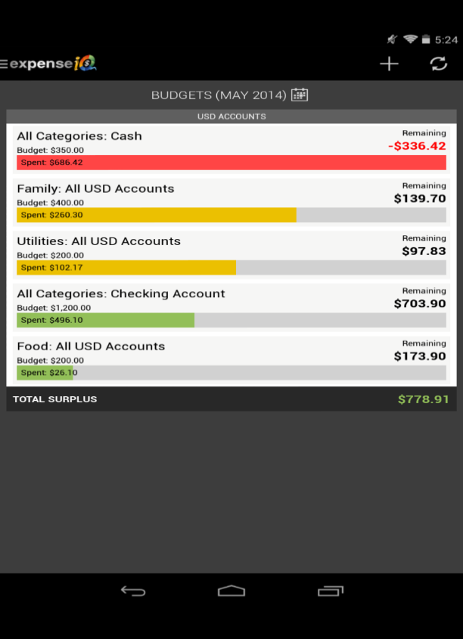 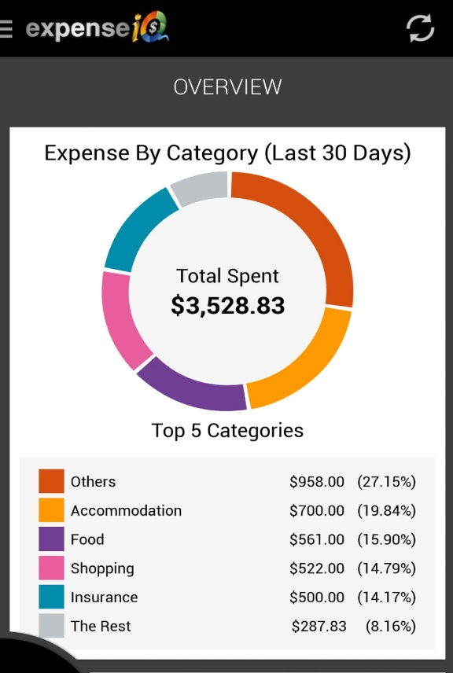

**Figure 1 Budget Window and Overview of Expense**

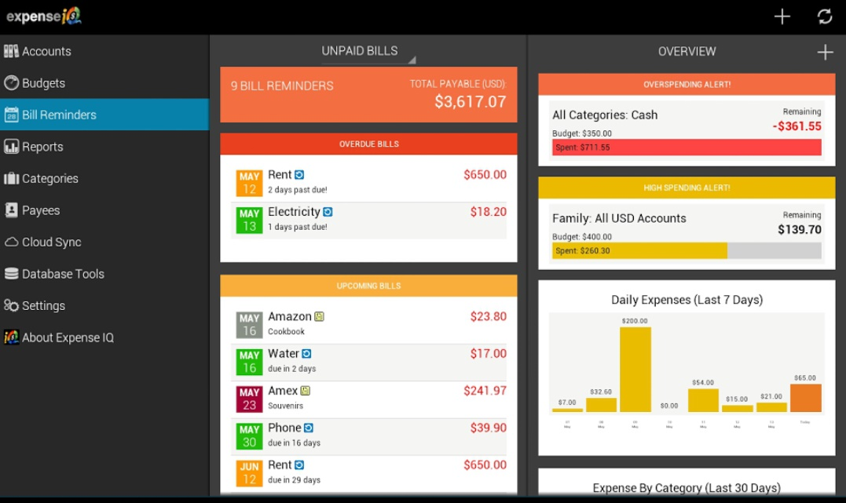

**Figure 2 Bill Reminder and Over Spending Alert Window**

## **2.5 User Characteristics**

This app is for users interested in monitoring their withdrawal rate so as not to fall on a deficit account status. The app has no age restriction. It can be used by everyone. There are no gender restrictions with the app usage. No special skill is required in operating the app. Supportive dialogues and attractive interfaces will be used to enable users feel more comfortable.

## **2.6 Design and Implementation Constraints**

The app is only compatible with new generation smart mobile devices. This include devices that runs on android platform (including tablets), iOS devices, Blackberry devices and even Windows phones. Android version 4.0 is the preferred OS for android devices. Users with other mobile devices may be required to have the latest version of their device’s operating systems running, for Banker Buddy to perform adequately. Banker Buddy is a mobile app and is not expected to run on a personal computer.

Input devices such as mouse and keyboard are not required to use the app since it will be built solely for touch screen devices. External speakers are also not required in using the app.

The app is not a game and does not provide any form of entertainment to users.

## **2.7 Assumptions**

This SRS assumes that:

* Users have a prior knowledge in operating smart devices that runs on android platforms
* User’s mobile devices runs on the latest operating system available
* Users haves email accounts
* User Understands English
* Users are able to read and understand information displayed on charts and graphs
* Users understands basic mathematical calculations like addition and subtraction
* An estimate of 10 Mb free spaces will be enough to install app.

# 3.0 Functional Requirements

## 3.1 The app shall display a splash screen

**Description**

On clicking the app icon, a splash screen is displayed for 3000 milliseconds

Pre-condition – User has downloaded and installed Banker Buddy

Post-condition – The login page is displayed

## 3.2 The app shall display a login page

**Description**

A login page is displayed and the user is prompted to enter a username and pin.

**Pre-condition** – User has a valid username and pin.

**Post-condition** - The home page of the app is displayed if username and password is valid, else an error message is displayed.

## 3.3 The app shall let the user create a new account

**Description**

The app shall let the user create a username and pin if the “Create Account” is selected

**Precondition** – User selects the “create account” button on the login page

**Post-condition** – The user is required to enter the details of the new account on the login page. This include: Username, Email, and Pin, and Confirm Pin. After the user selects the “Continue” button the app navigates to a new screen where **the user can set the threshold and beginning balance.** The “set threshold” function can also be done by selecting the “Settings” button found on the app’s sliding menu.

## 3.4 The app shall let the user save the new account details

**Description**

After entering the new account details, the user can save the new data to database by clicking the “+” button.

**Pre-condition –** User selected the “Create Account” button

**Post-condition –** New account details is saved to database after the user selects the “+” button and user goes to the home screen.

## 3.5 The app shall display the home screen

**Description**

The Banker Buddy home screen is displayed. The home screen contains a summary of the user’s last five transactions in a table. It also shows the current account balance and graph that displays the balance history after the last eight transactions.

**Pre-condition –** User was able to provide a valid username and pin on the login screen.

**Post-condition –** User can toggle the Menu button to select any of the following screens: “Deposit” “Withdraw” “Visualizations “Settings” “About `A” “Send Feedback” “Help” “Log Out”

## 3.6 The app shall allow the user make a deposit

**Description**

The user can make deposits by selecting the “Deposit” button from the sliding menu. From this menu the user selects the amount he wishes to deposit ($20, $50, $100). After selecting the amount, a message asking the user to confirm deposit pops up. If the user wishes to deposit a different amount, he can do so with the “Other Amount” button. The user enters the amount and selects “Deposit”.

**Pre-condition –** User selected the “Deposit” button from the home page menu.

**Post-condition –** User is presented with the confirmation screen.

## 3.7 The app shall display a confirmation screen

**Description**

A confirmation message pops up asking the user if he wants to make a deposit or not.

**Pre-condition –** The user entered an amount to be deposited.

**Post-**condition – If the user selects “No” he returns to the deposit screen. If “Yes” is selected, the deposit is confirmed and the home screen is displayed.

## 3.8 The app shall allow the user make withdrawals

**Description**

The user can make withdrawals by selecting the “Withdraw” button from the home page menu. From this menu the user enters the required amount he wishes to withdraw and this is saved when the “Make Withdrawal” button is selected.

**Pre-condition –** User selected the “Withdraw” button from the home page menu.

**Post-condition –** User returns to the home screen and his current account details is displayed. If the user already exceeds his threshold limit, his account balance will be displayed in red.

## 3.9 The app shall display a confirmation screen

**Description**

A confirmation message pops up asking the user if he wants to make a withdrawal or not.

**Pre-condition –** The user entered an amount to be withdrawn.

**Post-**condition – If the user selects “No” he returns to the withdraw screen. If “Yes” is selected, the withdrawal is confirmed and the home screen is displayed.

## 3.10 The app shall prevent the user from withdrawing an amount that is more than the available balance

**Description**

If the user tries to withdraw an amount that is greater than his available balance, a dialog box is displayed telling the user that he does not have sufficient funds.

**Pre-condition –** The user entered an amount to be withdrawn.

**Post-**condition – the user returns to the withdrawal screen.

## 3.11 The app shall allow the user to swipe between visualizations

**Description**

The user can select the visualization button to view charts and graphs of the account summary. The user can choose to view his summary in the form of a pie chart, bar graph, heat map, and an area chart, depending on which best suits his/her understanding.

**Pre-condition –** User selected the “Visualization” button from the sliding menu.

**Post-condition –** Graph continues to be displayed

## 3.12 The app shall allow the user manage the app’s settings

**Description**

The user manages the app’s settings by clicking the “Settings” button from the sliding menu.From this menu, the user can set threshold for his account. Account details can also be modified from this menu. User can set new threshold, change username or email, and pin. Email and Push notifications can also be enabled or disabled on this screen

**Pre-condition –** User selected the “Settings” button from the home page menu.

**Post-condition –** User saves new settings and returns to home screen containing his current account details.

## 3.13 The app shall allow the user to send feedbacks to the developers

**Description**

Feedback about the app can be sent to developers by selecting the “**Feedback**” button on the sliding menu. The feedback can either be a comment or a bug.

**Pre-condition –** User selected the “Feedback” button from the sliding menu.

**Post-condition –** User sends the feedback by clicking the “Send” button.

## 3.14 The app shall allow the user get help about using the app

**Description**

The user can watch a help video on how to use the app by selecting the “Help” button from the sliding menu.

**Pre-condition –** User selected the “Help” button from the sliding menu.

**Post-condition –** None

## 3.15 The app shall allow the user to logout of the app

**Description**

The user can logout of the app by selecting the “Logout” button from the sliding menu.

**Pre-condition –** User selected the “Logout” button from the sliding menu.

**Post-condition –** The app returns to the login screen

## 3.16 The app shall notify the user if he/she exceeds his threshold

**Description**

The user receives a push notification if the threshold amount already created is exceeded.

**Pre-condition –** User has already set his/her threshold from the “Create Account” menu or from the “Settings” menu.

**Post-condition –** User can save notification or delete

# 4.0 Quality Attributes for Banker Buddy

|  |  |
| --- | --- |
| **Quality Attribute** | **Brief Description** |
| **RT-1** | The app shall respond to a threshold alert in less than 2 seconds. |
| **RT-2** | The app shall send an alert/notification as soon as the user exceeds his threshold |
| **SS-1** | The app shall request for a username and password before the app’s home page is displayed. |
| **SA-1** | The app shall be available as long as it remains installed on the user’s mobile device. |
| **AC-1** | The system shall be accessible by android smart phones and tablets that has Banker Buddy already installed in them. |

**RE: response time**

**SS: system security**

**SA: system availability**

**AC: system accessibility**

# 5.0 Non-Functional Requirements

**Security:**

* The system ***will*** require the user to enter a valid username and password before access to the app is granted.
* All data stored on the device ***will*** be encrypted and only accessible by the application.

**Usability:**

* After starting the application the software ***will*** finish loading within 3000 milliseconds.
* When switching between screens, the system ***will*** load the next screen within 1000 milliseconds.

**Backup:**

* The system ***may*** allow the user to back up all data by compressing and encrypting the data into one file for safe storage.

# 6.0 Interface Requirement

## 6.1 GUI

When a user selects the Banker Buddy’s icon on his device, a splash screen is displayed for an estimated time of about 3000 milliseconds. What follows is a login screen requesting for the user’s username and password. The login page also contains a “create Account” button that enables the user to create a new account. After the user is able to gain access to the app, the home page is displayed, where the user can toggle between the different sections of the app by selecting from the main menu located on the top left corner of the screen.

The user can make deposits, withdrawals, set threshold, and view account summary from the user interface. The user can also send feedback to the developers by selecting the “Feedback” button. Below is the GUI for the login screen and the “create new account” screen. Details of the whole interface can be found in the appendix of this document.

Login Screen Create New Account Screen

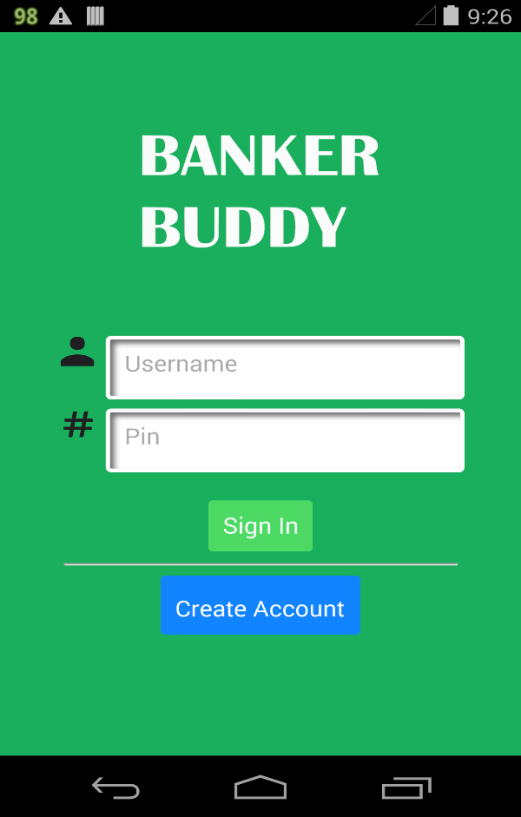 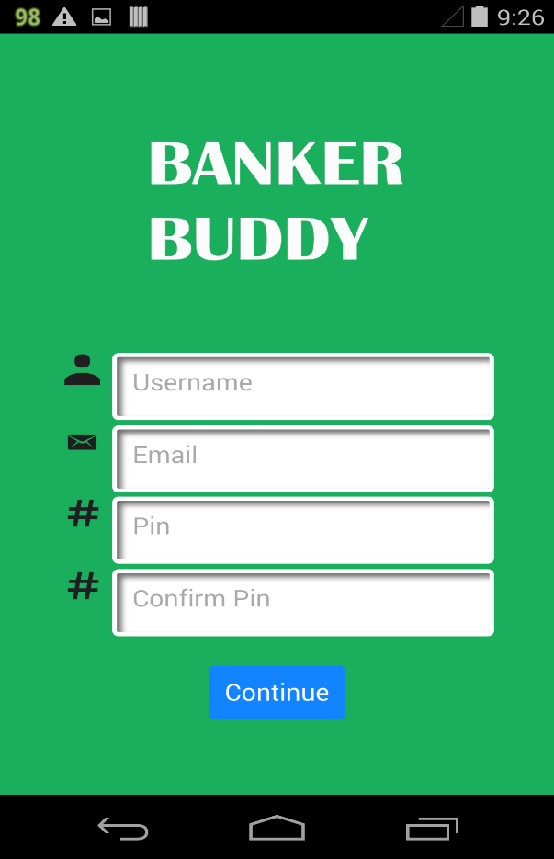

**Figure 3 User Interface for Login screen and Create New Account**

## 6.2 Hardware Interfaces

This application is expected to function optimally on touch screen mobile devices, including tablets. The app requires optionally that devices should have working speakers, as the software usage is accompanied by click sounds. ***Please note***: This requirement does not hinder the basic functionalities of Banker Buddy.

Before downloading and installing the app, a minimum of 100Mb internal storage space is required to be available. The app is expected to work best on devices with CPU speed of 1GHz and a 512MB RAM.

## 6.3 Software Interfaces

The Software interface of this app is already stated in the “Operating Environment” section above

# 7.0 SWOT Analysis for Banker Buddy

**Strengths:**

S1: Since the scope of this project is not so wide, the expected functionality of the app can realized before the product’s deadline. This means that all the functional requirements will be met.

S2: The software tools and techniques required for developing this mobile app is readily available and is within our reach.

S3: Since this project is a course work in the 462 class, it requires little or no form of financial support. Therefore we can say that this project is economically feasible.

**Weakness:**

W1: Although this group consists of students with a good background in software design and also good programming skills, this is the first time we are building a mobile application. This is actually a weakness because more time is spent learning how to use the software tools instead of producing the product. This may actually affect the project’s schedule.

W2: Since this is the first version of the app, it lacks certain functionalities compared to other budget assistant apps in the market. But subsequent versions will have more functionalities.

**Opportunities:**

O1: Almost everybody spends money on a daily basis. Most individuals find it difficult to keep track of their spending. This application therefore fulfils the interested user’s need for managing budgets.

O2: This project creates an avenue for us as a group, to learn new technology as well as new software design methods. Knowledge is gained in learning how to use the software tools required for building this mobile application.

**Threats:**

T1: Since this is a course work, other groups in the class are also developing a similar application. This is a threat because our team might be more focused on producing the best application by adding too many extra functions rather than producing the main product’s functionalities.

T2: There are also a lot of budget assistant applications already in the market and these products have a high recommendations and user ratings. This is a threat because it will be difficult for our new app to be able to break the market’s entry barrier.

# 8.0 UML Diagrams

## 8.1. Use Case Diagram

While on the main application screen, the user is presented with 4 options which provide functionality to the application. When the add income button is clicked, the user is presented with a screen that allows for the entering of an income that will then be added to a total budget. The manage budget option allows users to set up different categories such as “food”, “travel expenses”, and “entertainment” and give them a budget. If the user ever goes over a certain budget, the application will then notify the user how and why the event occurred.

The manage expense option allows users to log their expenses, which are then subtracted from each respective budget. Finally, the view report option allows the user see a detailed report explaining each expense and addition to the general budget.

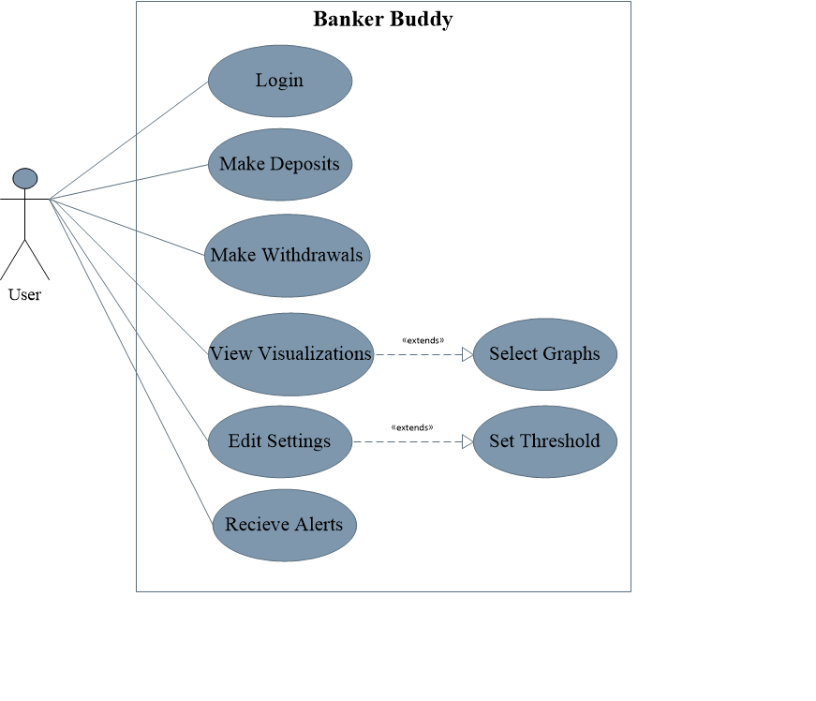

**Figure 4 Use Case diagram for Banker Buddy**

## 8.2 Sequence Diagram for Use Case Login

The sequence diagram describes how the user login information is validated. When the app is launched and the splash screen displays, the login screen follows. The user is required to enter his username and password every time the app is launched. This is done to ensure security. The main screen or home screen is only displayed if the user is able to provide a valid username and password.



**Figure 5 Sequence diagram for Use case Login**

## 8.3 Activity Diagram for Deposit and Withdraw

The activity diagram shows a description of all the processes involved in Depositing into an account and also withdrawing from the account. User needs to confirm both deposit and withdrawals before his account details will be updated, if a user tries to withdraw an amount greater than his current balance, the transaction will fail.



Check if there is sufficient funds

Yes

No

Yes

Yes

No

**Figure 6 Activity Diagram for Use Case Deposit and Withdraw**

# **APPENDIX A: USER OPERATIONS MANUAL**

This section of this document provides an understanding of how to use the Banker Buddy app.

1. **Splash Screen**

On loading the app from the device’s menu, the banker buddy splash screen is displayed and stays for about 3000 milliseconds (3 seconds).



**Figure 7 Screenshot of the Splash screen**

1. **Login**

Enter Username and Password to sign in and start using the app.

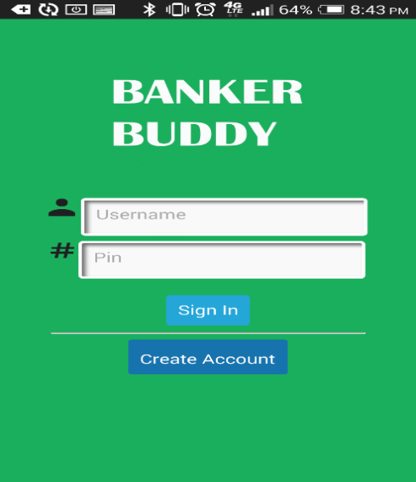

Figure 8 Screenshot of the login screen

1. **Create New Account**

If you are a first time user, you are required to create a username and password. This can be done by selecting the “Create Account” button from the login screen. In creating a new account, you are also required to set your threshold amount. You can decide to disable email notification and push notification as they are both enabled by default. It is ***highy recommended*** to leave the notifications enabled so as to recieve alerts in due time.

If you choose to disable your notifications at any time, you can do so from the “**Settings”** screen.

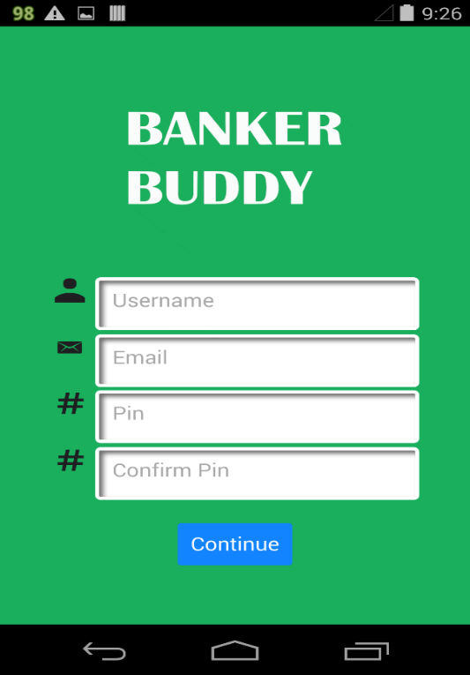 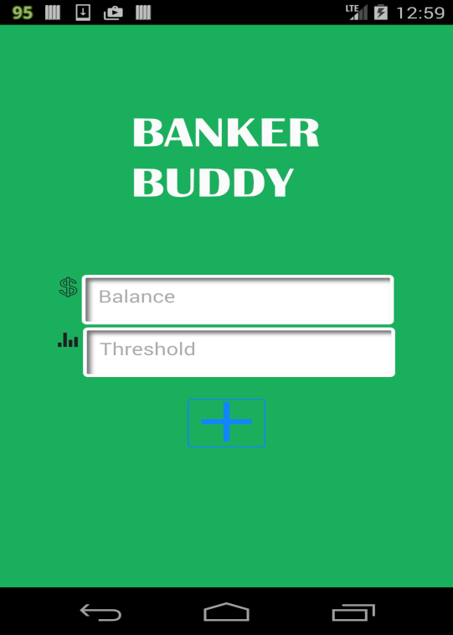

**Figure 9 Screenshot of the Create account screen**

1. **Home Screen**

After you are able to login with a valid username and password, the home screen is displayed. The home screen is a summary of your account. It displays your last five transaction history in the form of a list and also in a graphical format. You can also see your account balance on your home screen.

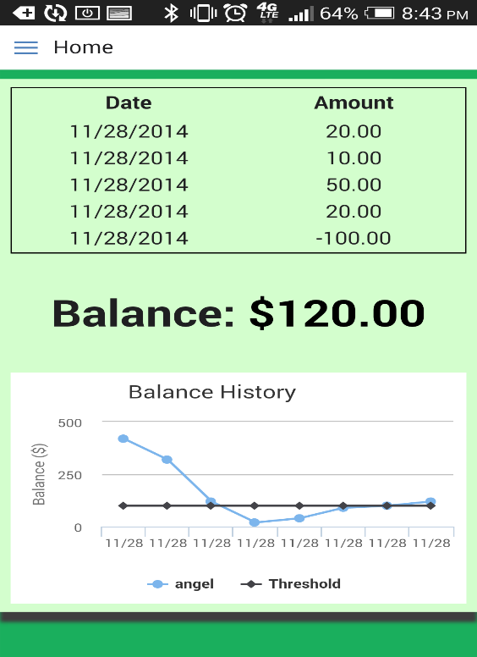

**Figure 10 Screenshot of Home Screen**

1. **Make Deposit**

To make a deposit, simply select “**Deposit**” from the **Menu** on the top left corner of the screen.

The deposit screen appears and you can choose the amount you wish to deposit. The available amounts to deposit are $20, $50, and $100. If you wish to deposit a different amount, you can do so by clicking the “**Other Amount**” button.

To complete a deposit, select the “**Deposit**” button. A message screen will appear. Choose “Yes” to complete transaction, and “No” to go back or cancel transaction.

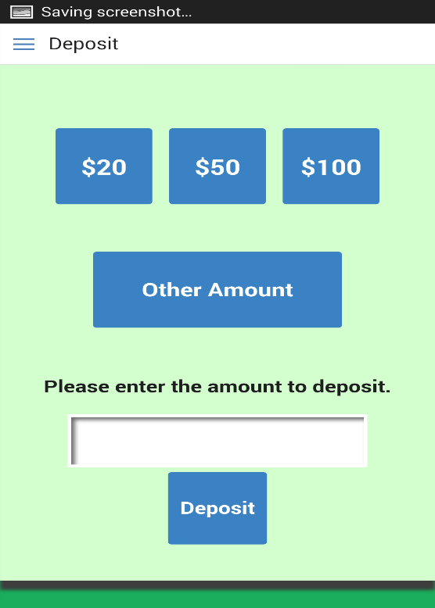

**Figure 11 Screenshot of the Deposit Screen**

1. **Make Withdrawals**

To make a withdrawal, simply select “**Withdraw**” from the “M**enu**” on the top left corner of the screen. The Withdraw screen appears and you can choose the amount you wish to withdraw. The available amounts to withdraw are $20, $50, and $100. If you wish to withdraw a different amount, you can do so by clicking the “**Other Amount**” button.

To complete a withdrawal, select the “**Withdraw**” button. A message screen will appear. Choose “Yes” to complete transaction, and “No” to go back or cancel transaction.

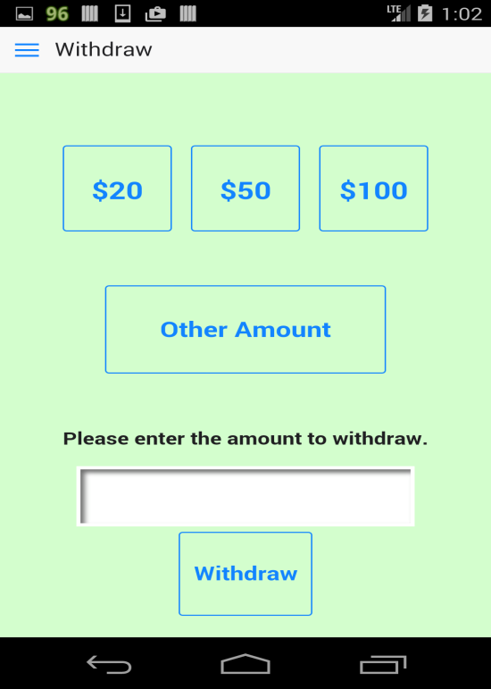

**Figure 12 Screenshot of the Withdraw screen**

1. **Settings**

Select the “**Settings**” button from the “**Menu**” on the top left corner of the screen to view and edit settings. You can change your login details on this screen by entering your new username and pin. Also, you can toggle the email and push notifications on or off.

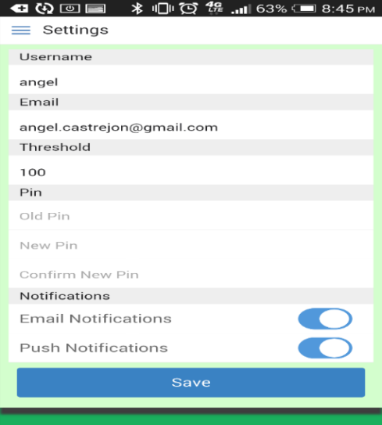

**Figure 13 Screenshot of the Settings Screen**

1. **Visualizations**

The Visualization displays a graphical summary of your account. You can view visualizations by selecting the “**Visualization**” button on the menu. You can swipe up and down to view all graphs.

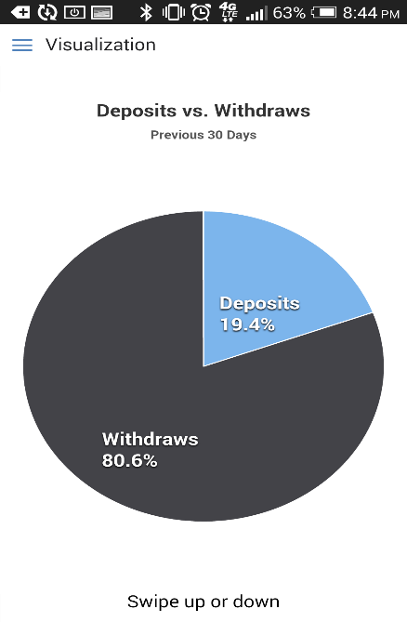 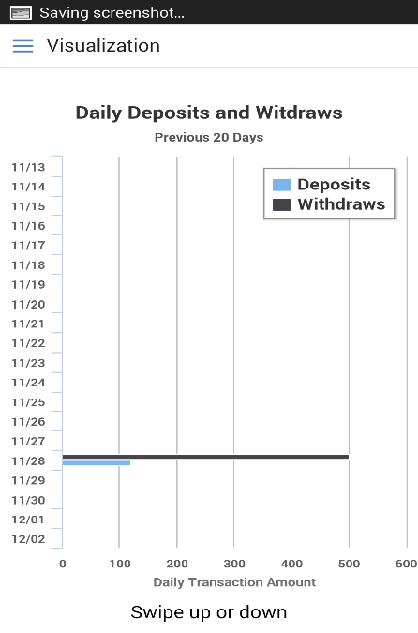

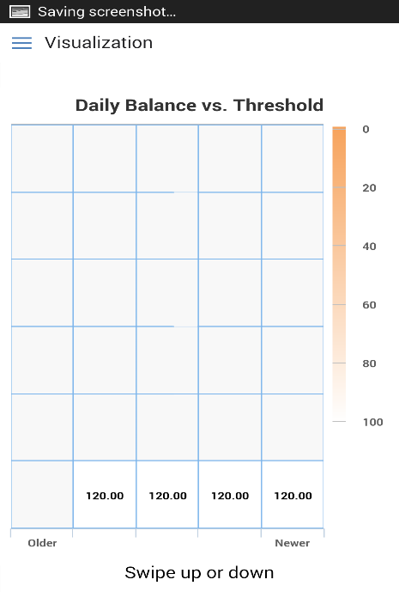 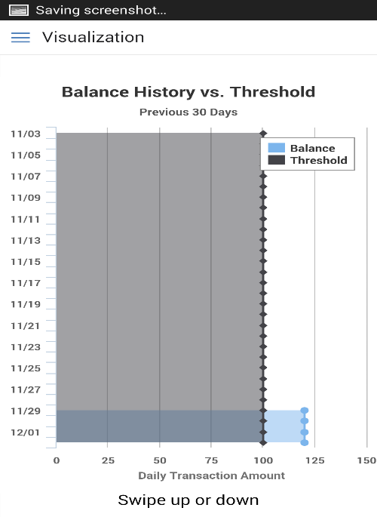

**Figure 14 Screenshot of all visualizations**

1. **Send Feedback**

Feedback about the app can be sent to developers by selecting the “**Feedback**” button on the menu. Select the type of feedback, either a comment or a bug. Enter subject of feedback and type a description of the feedback. Select “**Send**” to send feedback to developers.

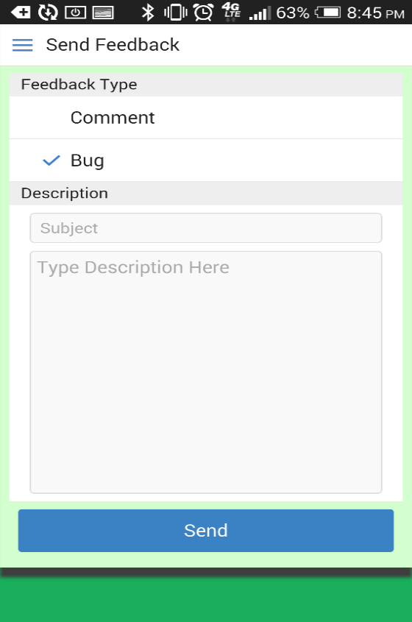

**Figure 15 Screenshot of the Send Feedback screen**

# **APPENDIX B: References and Tools Used**

**References**

Expense Manager iQ – Expense Manager by Handy Apps Inc

Group D, 2013. Software Requirements Specification for Model Student

Lecture Notes and Slides by Lidia Morrison

Lidia Morrison – Environment Monitoring Control (EMC) Systems

The Gioi Dang Vat Game, 2013. Software Requirements Specification

**Tools Used**

The following tools were used for developing this SRS and drawing all UML diagrams

* Microsoft Visio 2010
* Microsoft Word 2013